Lab 4: Microservices Decomposition & Communication
Activity Practice 1: Decomposition by Business Capability
1. Microservices in the system
Microservice | Function | Database | Port
Auth Service | Register, log in, JWT | DB_Auth | 5001
Profile Service | User profile management | DB_Profile | 5002
Product Service | Product Management | DB_Product | 5003
Category Service | Category Management | DB_Category | 5004
Brand Service | Brand management | DB_Brand | 5005
Cart Service | Shopping Cart Management | DB_Cart | 5006
Order Service | Manage COD orders | DB_Order | 5007
API Gateway | Request coordination | No data saved. | 8000

2. External components
Ingredient | Role
MySQL | Each service has its own database.
Local Storage (/uploads) | Save product images and avatars.
COD Payment | Payment upon delivery

Activity Practice 2: Service Contracts
Auth Service
API | Method | Function
/api/auth/register | POST | Register
/api/auth/login | POST | Log in

Profile Service
API | Method | Function
/api/profile | GET | Get the file
/api/profile | PUT | Update profile
/api/profile/avatar | PUT | Upload avatar

Product Service
API | Method | Function
/api/products | GET | Get the product list
/api/products/{id} | GET | Get product details
/api/products | POST | Add product
/api/products/{id} | PUT | Product update
/api/products/{id} | DELETE | Delete product

Category Service
API | Method | Function
/api/categories | GET | Get the catalog
/api/categories/{id} | GET | Category details
/api/categories | POST | Add category
/api/categories/{id} | PUT | Update the catalog.
/api/categories/{id} | DELETE | Delete category

Brand Service
API | Method | Function
/api/brands | GET | Branding
/api/brands/{id} | GET | Brand details
/api/brands | POST | Add brand
/api/brands/{id} | PUT | Brand update
/api/brands/{id} | DELETE | Remove the brand.

Cart Service
API | Method | Function
/api/cart | GET | Get the shopping cart
/api/cart | POST | Add to cart
/api/cart/{id} | PUT | Update quantity
/api/cart/{id} | DELETE | Remove from cart

Order Service
API | Method | Function
/api/orders | POST | Create a COD order
/api/orders/my | GET | Order history
/api/orders | GET | Order list
/api/orders/{id}/status | PUT | Update status

Rules for communication between services
Correct
Cart Service
↓
GET /api/products/{id}
↓
Product Service
Order Service
↓
GET /api/cart
↓
Cart Service

Until
Cart Service → access DB_Product directly
Order Service → Directly access DB_Cart
This violates the principles of Microservices Architecture.

Activity Practice 3: Communication Strategy
Interact | Communication style
Log in | Synchronous HTTP
View products | Synchronous HTTP
Shopping Cart Management | Synchronous HTTP
Cash on delivery (COD) | Synchronous HTTP
Check inventory | Synchronous HTTP
The system currently only uses Synchronous Communication because it does not yet have integrated email or online payment.

C4 Model - Level 1: System Context
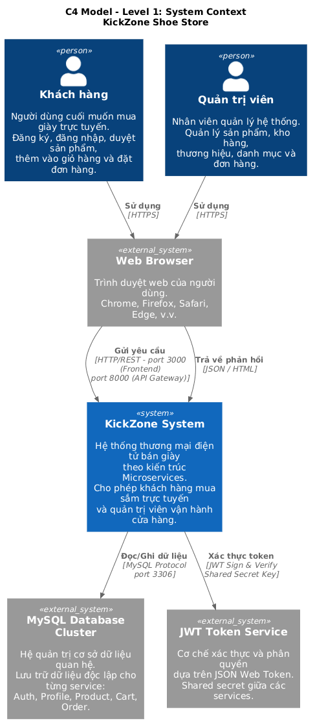
C4 Model – Level 2: Container Diagram

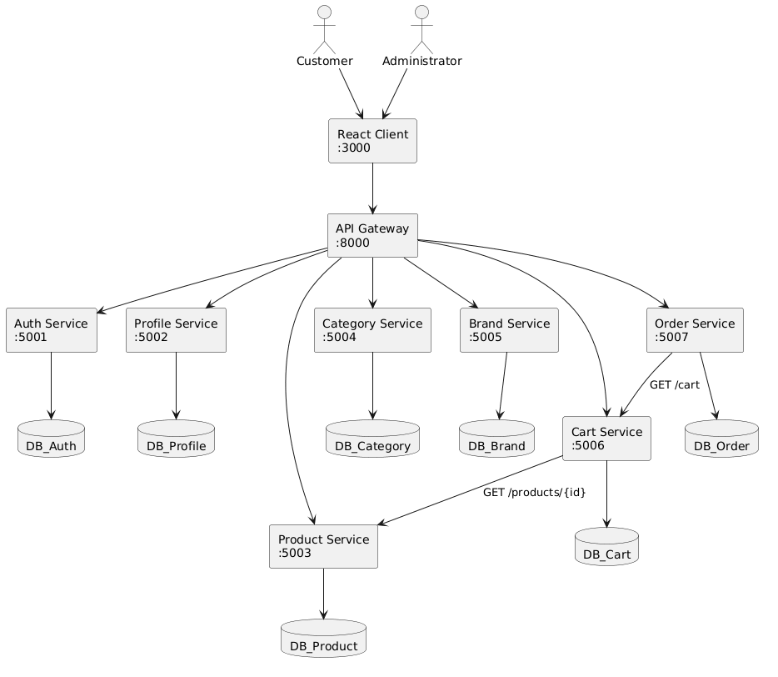

C4 Model – Level 3: Component Diagram (API Gateway)
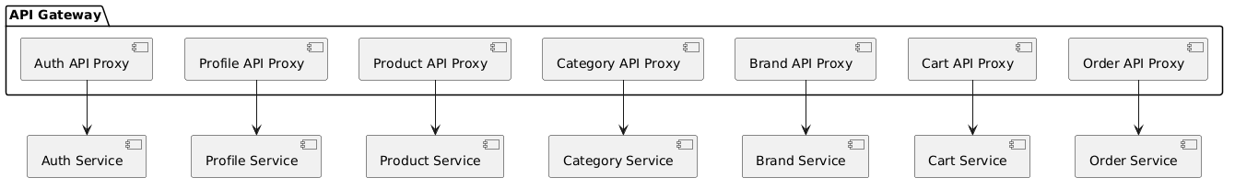
Level 3 – Product Service

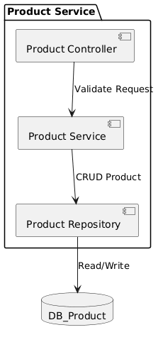
Level 3 – Order Service

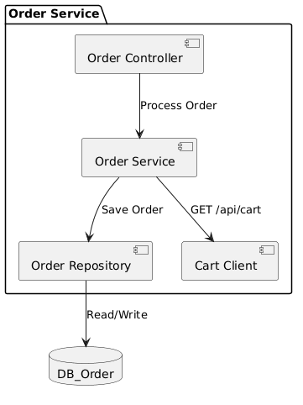
Level 4 Order Service
